EXP 15
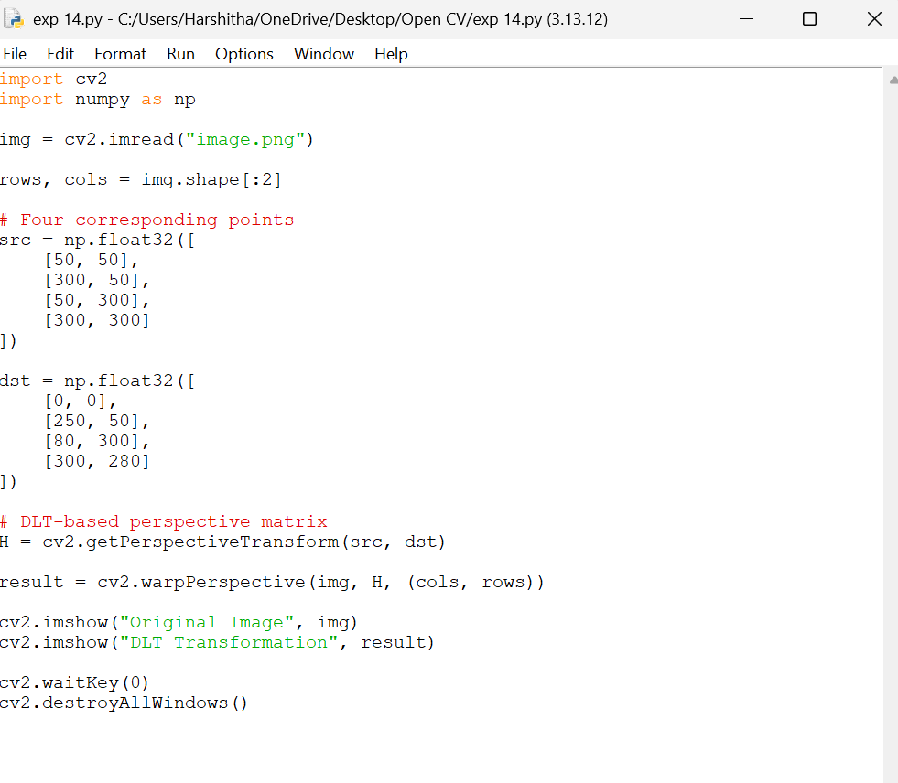
Aim:
To perform image transformation using the Direct Linear Transformation (DLT) algorithm in OpenCV with Python by estimating the transformation matrix from corresponding points and applying it to obtain the transformed image.
